Henry, Joseph (from University of Sydney website)
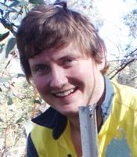
BSc Forestry Hons ANU c2012.
Has lived in and around the Southern Tablelands of NSW . Honours research topic was the impact of riparian willows on water quality along the Murrumbidgee River at Bredbo and Angle Crossing. He received the Doug Brodie Award for the best all round fourth year forester whilst at the ANU.
Research student at University of Sydney in 2013. Research aims to develop techniques and models to scale water balances up and down from tree to catchment (spatial) and sub-daily to yearly (temporal) scales. This will be used to understand where water is being lost from the catchment area of Corin Reservoir, ACT.

